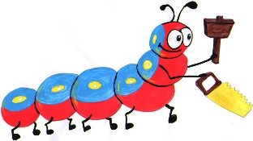

Lyng Primary School Knowledge Organiser

Design Technology



Cake Stands (Victorians)

Year 6

Topic: DT

Spring

|  |  |
| --- | --- |
| What Goldilocks and Step On words will I use? | |
| **Spelling** | **Defintion** |
| mark out | To measure and mark where a piece of material needs to be cut or shaped. |
| modify | To change something to improve or fix it. |
| prototype | A simple model that lets you test out your idea and how it will look and work. |
| reinforce | To make another structure or material stronger, especially by adding another material or element to it. |
| Structure | Something which stands, usually on it is own. |
| User | A pesron that uses something. |



**Design Brief for pupils:**Children to analyse the different styles of cake stands and then make their own. Children to take inspiration from the style of William Morris.

**Spring Term –**

Construction

|  |
| --- |
| Skills and techniques |
| * Combine elements of design from a range of inspirational designers throughout history, giving reasons for choices. * Create innovative designs that improve upon existing products. * Evaluate the design of products so as to suggest improvements to the user experience. |

**Did you know?**

It's the seventh Duchess of Bedford, Anna Maria Russell, who we have to thank for the invention of afternoon tea, sometime around 1840. Due to increasing urbanisation and the rise in industrialisation (including the spread of gas lighting in England), the evening meal was becoming later and later.

The Duchess of Bedford, who was one of Queen Victoria's ladies-in-waiting, was having none of it. Describing a 'sinking feeling' at about 5pm, she became despondent at the void between lunch and dinner. She requested that some tea, bread and butter and cake was brought to her room in the late afternoon – and with that one request of a lady's grumbling stomach, an afternoon ritual was born. Needing very little prompting to find an occasion to squeeze in another cup of tea and a piece of cake, the upper classes ate it up and the fashionable custom soon spread across Britain.

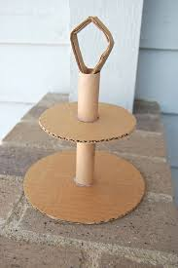

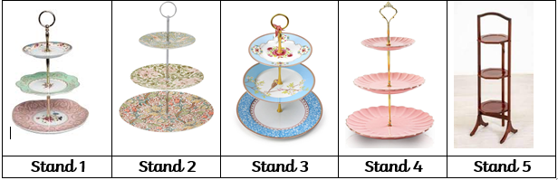

**Agreed outcome:** Victorian Inspired Cake Stand